Assignment 1 Screenshots

* Docker File:

* Index (HTML):

* Config (default.conf):

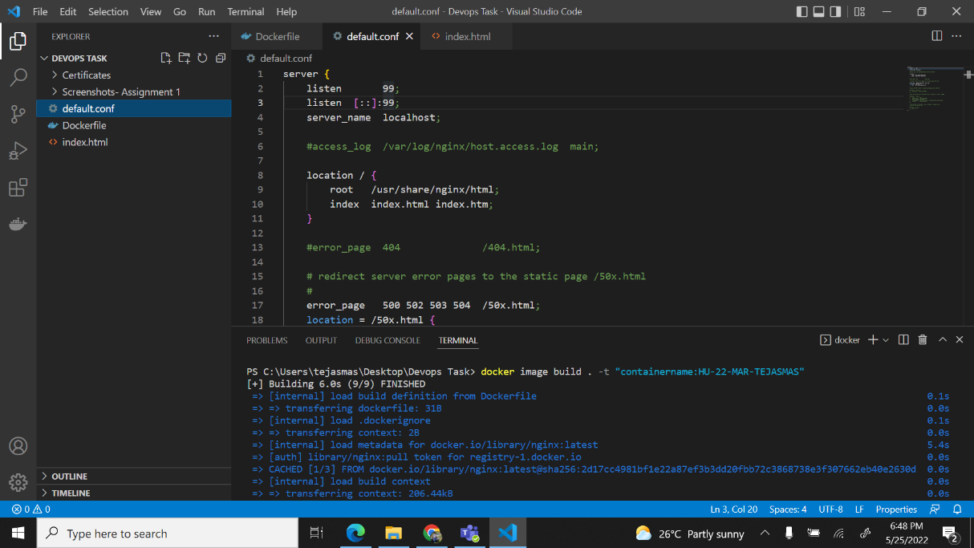

* Build code:

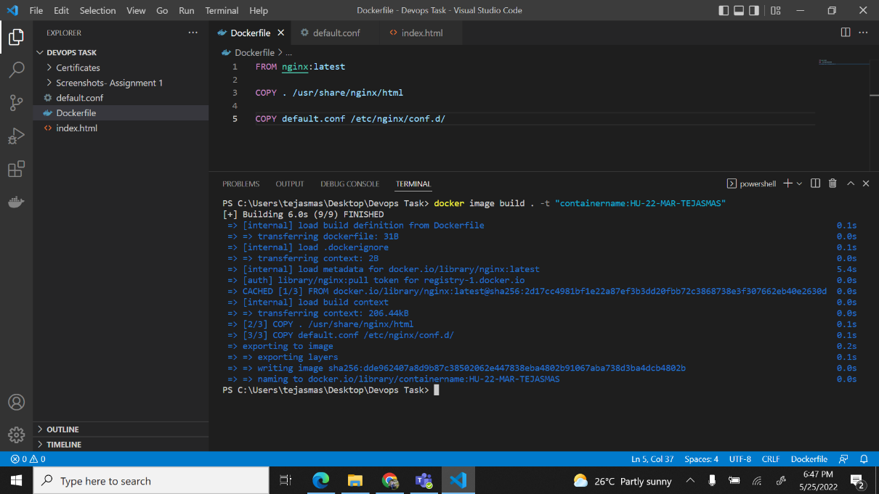

* Run code:

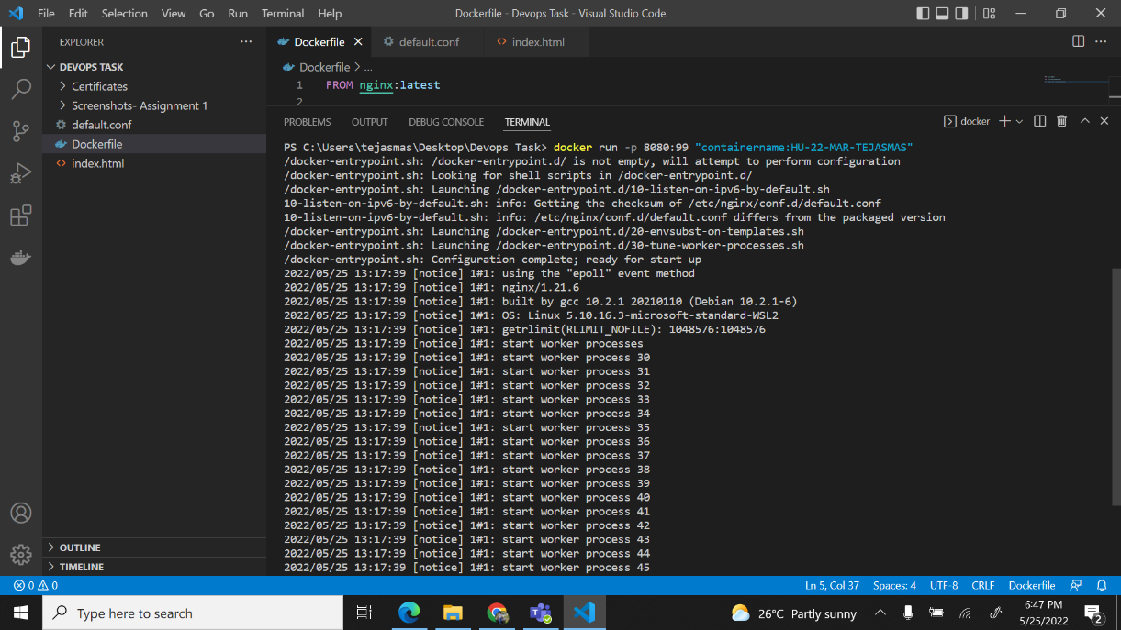

* Webpage on local host:

